## Project

The project is a restaurant management system. The project is done using C#.NET and has database of MYSQL. There are multiple Forms each having their own function which have been assigned to main category.

The following WinForms are:

Initial:

* User.cs (Sign In)
* RegisterForms.cs (Sign Up)

Users:

* Main.cs (Admin)
* Chef.cs
* Cashier.cs
* Rider.cs
* Waiter.cs

Sub Category:

* Payment.cs

AddPayments.cs

* Pos.cs
* Recipe.cs
* Salary.cs
* Sales.cs
* Table.cs
* Delivery.cs
* Users.cs (User List)

AddUsers.cs

* Inbox.cs
* Info.cs
* Inventory.cs

AddItems.cs

* Menu.cs
* Order.cs

### Initial

The initial part is the first form when we run the program. As shown in the figure below we have the log in page for the users to enter their username and password including there type of account since the system contain an administrative aspect to it. Once the username and the password is matched after clicking the login button it goes to their respective main Form depending on the type of account.

It also has the option for Signing Up which will lead to the Register Form as shown in Figure 120.

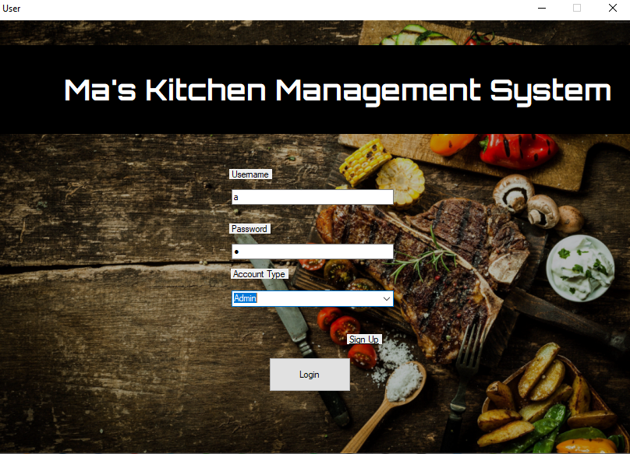

Figure (User.cs, 2020)

In the Register Form there are textboxes to fill for a new user. It contains First, Last name, email, username and password. Once the details are added and the Create Account button is clicked it will add the user and go the User Form.

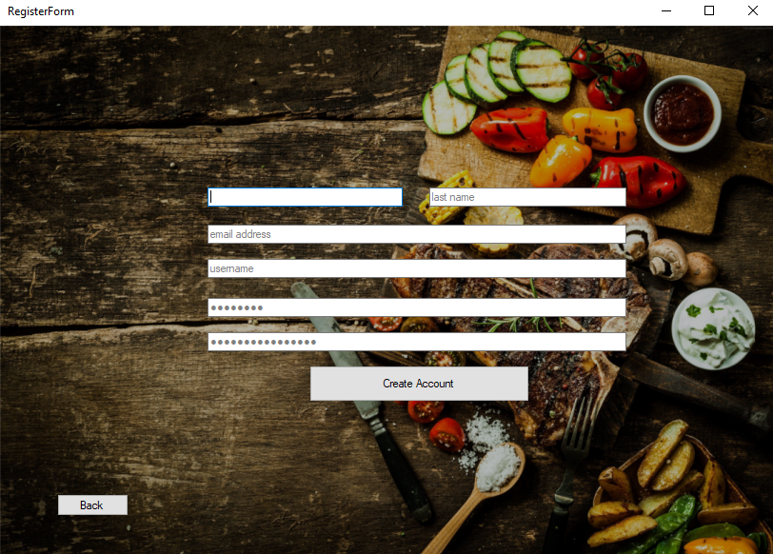

Figure (RegisterForm.cs, 2020)

### Users

The users are the Forms that appears once the login is successful, it contains five user types which are:

#### Admin

The Admin contain couple of section for it to manage, the following are:

* Order
* User
* Payment
* Inventory
* Sales
* Inbox

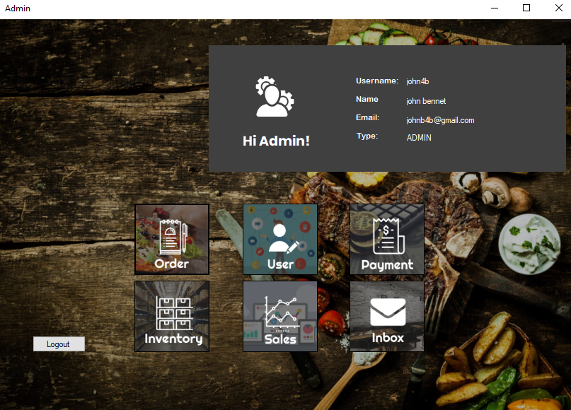

Figure (Main.cs, 2020)

#### Chef

The Chef contain couple of section for it to manage, the following are:

* Recipe
* Menu
* Salary
* Info

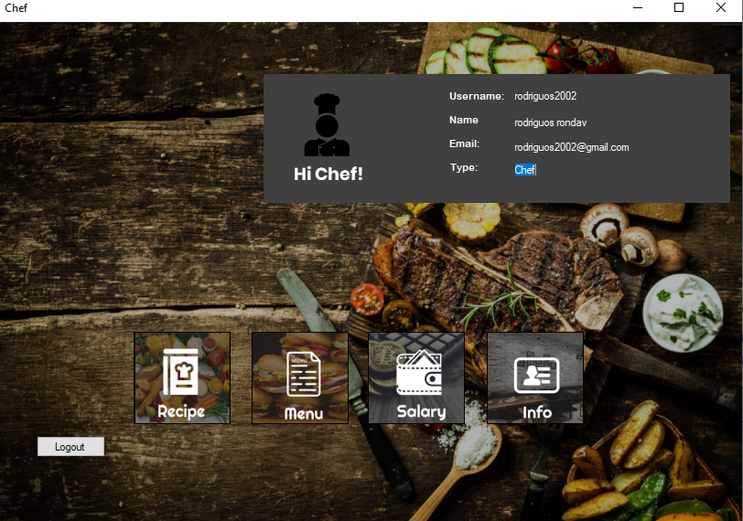

Figure (chef.cs, 2020)

#### Cashier

The Cashier contain couple of section for it to manage, the following are:

* POS
* Menu
* Salary
* Info

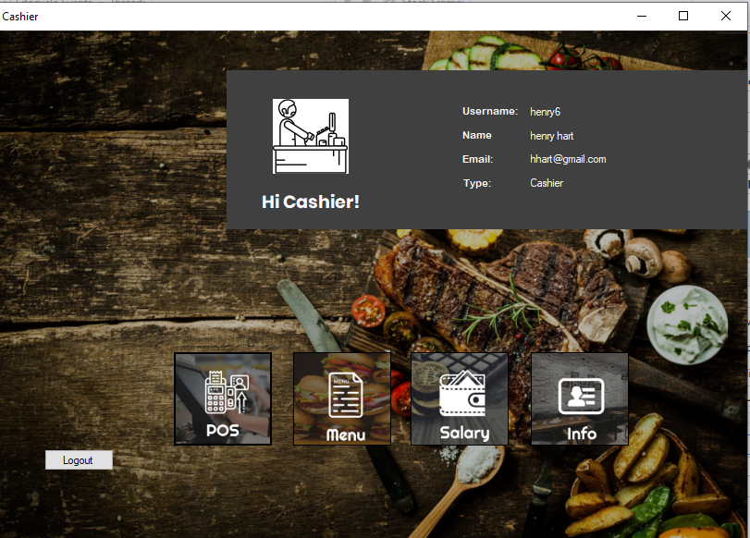

Figure (Cashier.cs, 2020)

#### Rider

The Rider contain couple of section for it to manage, the following are:

* Delivery
* Menu
* Salary
* Info

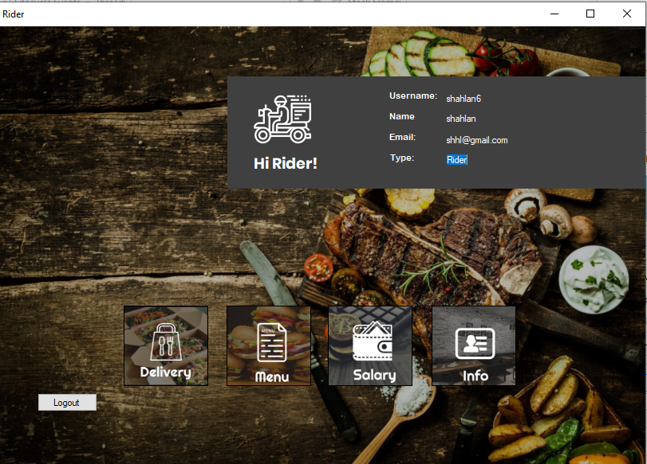

Figure (Rider.cs, 2020)

#### Waiter

The Waiter contain couple of section for it to manage, the following are:

* Table
* Menu
* Salary
* Info

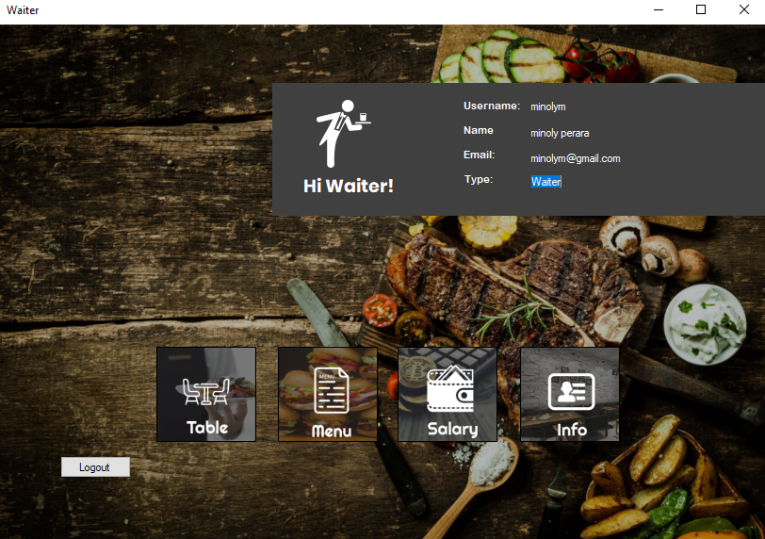

Figure (Waiter.cs, 2020)

### Sub Category

These are function illustrated as Forms which are the following:

#### Order

It contains all the orders given in the restaurant since all are done in the system. Admin can view them and can even remove them if need be.

#### Users

The Users Form has all the users detail shown in a table in the system. Admin can remove a user and even add a user (Figure 127).

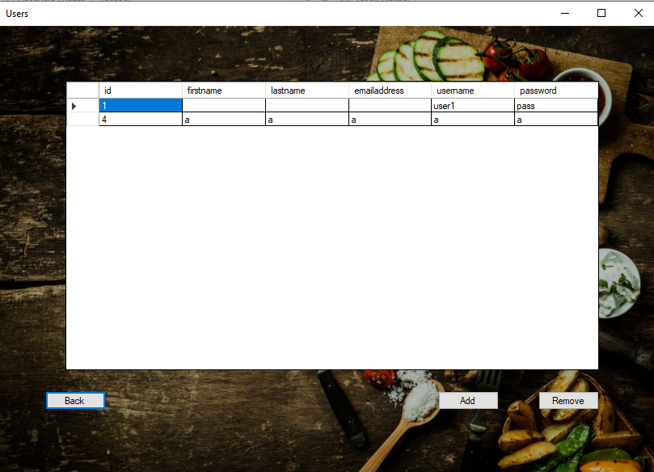

Figure (Users.cs, 2020)

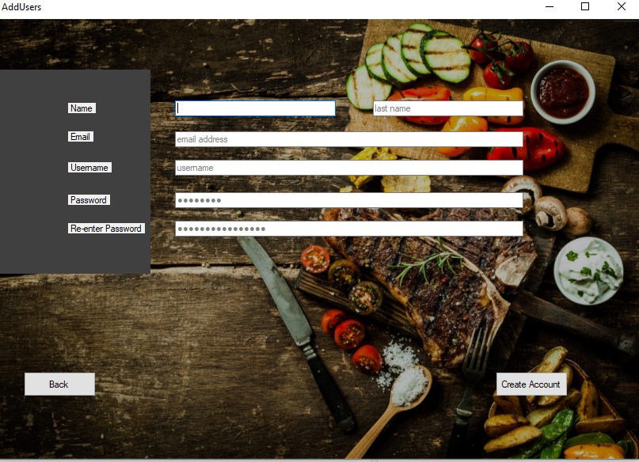

Figure (AddUser.cs 2020)

#### Payment

The payment Form contain all the payment details of the customer. It contains the time, payment method, total, balance and etc. The admin also can add a payment as shown in Figure 129 and remove the once the he/she wants.

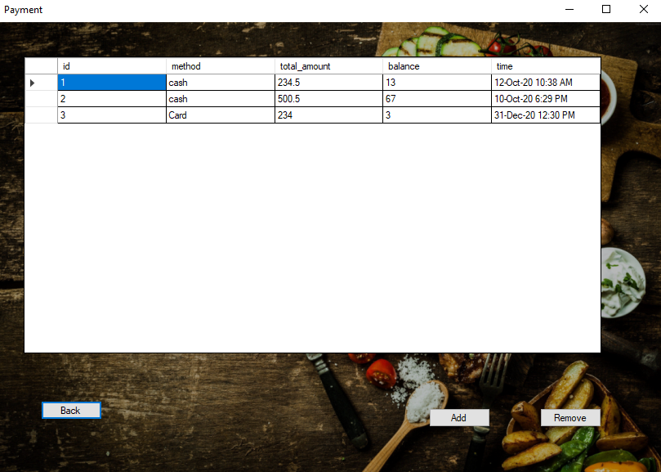

Figure (Payment.cs, 2020)

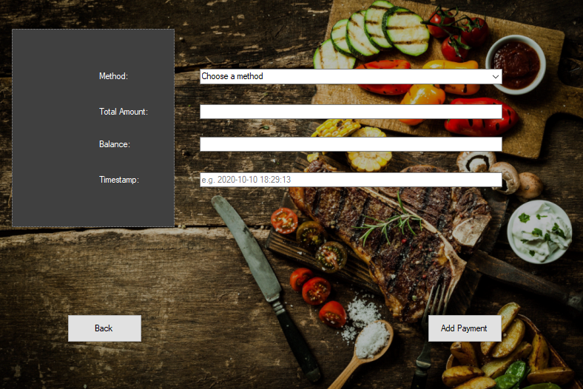

Figure (AddPayment.cs, 2020)

#### Inventory

The inventory Form contain the details of the items in the stock. It tells the Admin if the restaurant is out of stock or not. It also has the function to let the admin to add as shown in Figure 131 and remove any items needed.

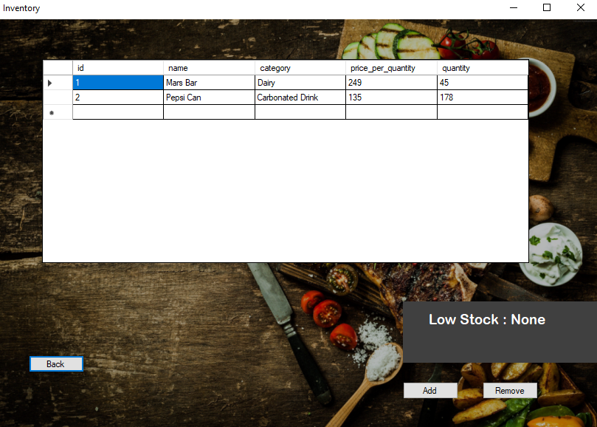

Figure (Inventory.cs, 2020)

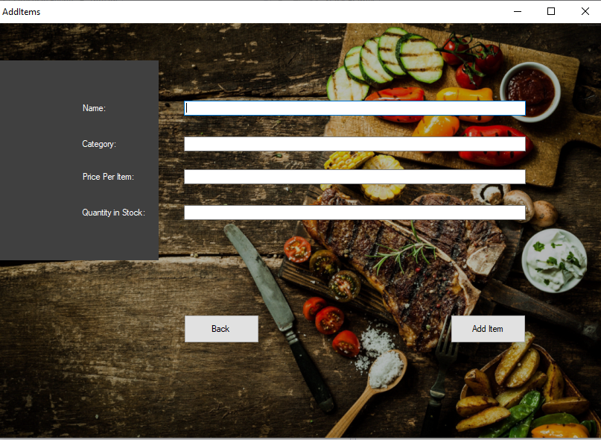

Figure (Additems.cs, 2020)

#### Sales

The Sales Form shows admin the analytics of the sales. It shows the total Items Sold for the entire year that are represented by a Bar Chart as shown in Figure 132.

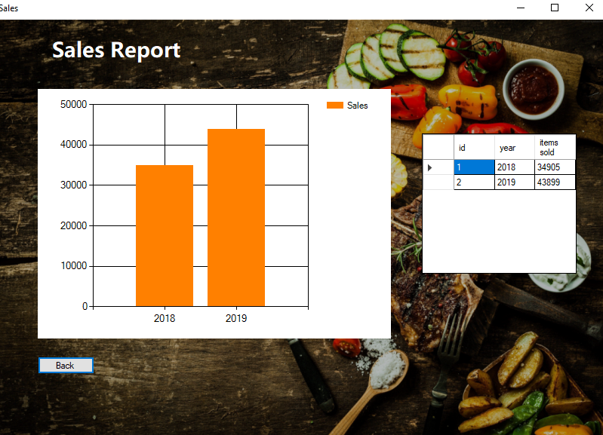

Figure (Sales.cs, 2020)

#### Inbox

Since the admin is the once to supervise, the inbox Form has all the emails or messages sent to the admin regarding the restaurant. The Admin can reply to the mails and delete, similar to a general email inbox.

#### Recipe

The Recipe Form contain all the details for the menu and is assigned into the Chef Form since he/she will the one to using it the most.

#### Point of Sale

The point of sale is a simple system that can take an order and print a digital receipt that will be shown to the customer and be saving in the payment Form later.

#### Delivery

The delivery Form contains the function of taking an order and to show the detail of the customer to be able to communicate properly, as well as help to commute for efficiently. Which is why this Form is in the Rider section.

#### Table

The table Form has a simple table system so that the waiter can work efficiently which is why it is in the Waiter Form.

#### Menu

The menu Form is one of the Form that is included in Rider, Chef, Cashier and Waiter since they all will be using it wisely. The menu contains all the menu details like the recipe layout.

#### Salary

The Salary Form is one of the Form that is included in Rider, Chef, Cashier and Waiter since they all will be using it wisely. The salary Form contain the salary details of the employees which include the annual, semi-annual, quarterly and monthly income.

#### Info

The Info Form is one of the Form that is included in Rider, Chef, Cashier and Waiter since they all will be using it wisely. The Info contain the Profile details such as the name, age, NIC and so forth.

## Code

In the Folder as “restaurantSystem”.